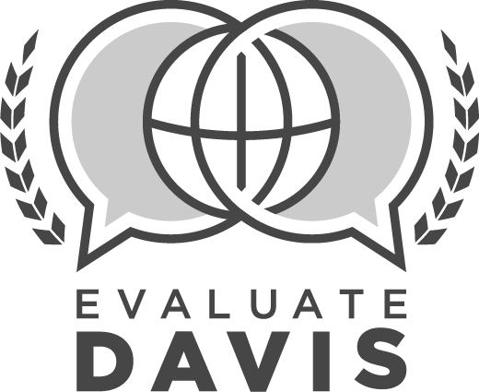
CLASSIFIED EMPLOYEE
SUMMATIVE EVALUATION

Employee: |  |  | Assignment:
Employee ID #: |  |  | Date:
School/Department: |  |  | School Year:

SUMMATIVE EVALUATION PRE-CONFERENCE
To be completed before employee conference
1 | Sources of evidence: A minimum of 2 sources of evidence must be used in the evaluation  Work observation  Information from others (phone calls, emails, letters, discussions, etc.)  Department checklist or inventory  Survey data  Data (work order, etc. specify in comments box)  Evidence unique to department and/or employee (specify in comments box)  Other (specify in comments box)  Optional Comments:
2 | Review of prior evaluations  No or Not Applicable (comments required)  Yes (comments optional) |  |  |  | Comments:
PLAN
3 | (P.1) Works with co-workers and supervisor/s to plan for implementation of department vision and goals
 | Ineffective  Moderately Effective  Effective  Highly Effective |  | Optional Comments:
4 | (P.2) Plans and organizes to manage work tasks efficiently
 | Ineffective  Moderately Effective  Effective  Highly Effective |  | Optional Comments:
5 | (P.3) Maximizes the use of district resources through effective planning
 | Ineffective  Moderately Effective  Effective  Highly Effective |  | Optional Comments:
DO
6 | (D.1) Demonstrates and performs essential job functions with minimal instruction
 | Ineffective  Moderately Effective  Effective  Highly Effective |  | Optional Comments:
7 | (D.2) Shows initiative and interest in work projects
 | Ineffective  Moderately Effective  Effective  Highly Effective |  | Optional Comments:
8 | (D.3) Completes work in a timely manner
 | Ineffective  Moderately Effective  Effective  Highly Effective |  | Optional Comments:
9 | (D.4) Uses resources and equipment in a safe and appropriate manner
 | Ineffective  Moderately Effective  Effective  Highly Effective |  | Optional Comments:
10 | (D.5) Demonstrates flexibility and good judgment in handling daily routines and emergencies
 | Ineffective  Moderately Effective  Effective  Highly Effective |  | Optional Comments:
CHECK
11 | (C.1) Performs work with accuracy and neatness
 | Ineffective  Moderately Effective  Effective  Highly Effective |  | Optional Comments:
12 | (C.2) Seeks and uses feedback to guide adjustments for continuous improvement
 | Ineffective  Moderately Effective  Effective  Highly Effective |  | Optional Comments:
13 | (C.3) Consistently follows up on requests to ensure problems are solved and needs are met
 | Ineffective  Moderately Effective  Effective  Highly Effective |  | Optional Comments:
14 | (C.4) Communicates with supervisor regularly to evaluate performance and project management
 | Ineffective  Moderately Effective  Effective  Highly Effective |  | Optional Comments:
ENVIRONMENT
15 | (E.1) Maintains a safe and orderly work area
 | Ineffective  Moderately Effective  Effective  Highly Effective |  | Optional Comments:
16 | (E.2) Fosters a productive environment through effective time management, organization, and appropriate allocation of resources
 | Ineffective  Moderately Effective  Effective  Highly Effective |  | Optional Comments:
17 | (E.3) Maintains professional appearance appropriate to duties, tasks, job description, and department expectations
 | Ineffective  Moderately Effective  Effective  Highly Effective |  | Optional Comments:
18 | (E.4) Fosters an environment where employees are positive and respectful
 | Ineffective  Moderately Effective  Effective  Highly Effective |  | Optional Comments:
PROFESSIONALISM
19 | (PRO.1) Engages in self-reflection and professional learning for continuous growth and expertise
 | Ineffective  Moderately Effective  Effective  Highly Effective |  | Optional Comments:
20 | (PRO.2) Collaborates and cultivates positive productive relationships with supervisors, co-workers, school staff, students, and community
 | Ineffective  Moderately Effective  Effective  Highly Effective |  | Optional Comments:
21 | (PRO.3) Approaches challenges and changes positively
 | Ineffective  Moderately Effective  Effective  Highly Effective |  | Optional Comments:
22 | Adheres to all school, district, and state policies and procedures with consistency.
 | No (comments required)  Yes (comments optional) |  | Comments:
23 | Commendations, Recommendations, Other:
SUMMATIVE EVALUATION CONFERENCE
To be completed with employee
PROFESSIONAL GROWTH PLAN:
24 | Training or Professional Development Review  Complete |  | Optional Comments:
25 | Professional Contributions  Complete |  | List:
26 | (PRO.4) Makes professional contributions to department and/or school community
 | Ineffective  Moderately Effective  Effective  Highly Effective |  | Optional Comments:
REVIEW OF GOALS
Performance Goal #1 |  | No progress toward goal |  | Progress made toward goal |  | Met goal
Performance Goal #2 |  | No progress toward goal |  | Progress made toward goal |  | Met goal

Employee Signature | Date |  | Supervisor Signature | Date

