MESA MOUSETRAP CAR 2019

A State MESA Competition at USU Physics Day at Lagoon



**Event Registration:** <https://www.surveymonkey.com/r/mesamousetrap19> *All registrations are due by Friday, May 10, 2019.*

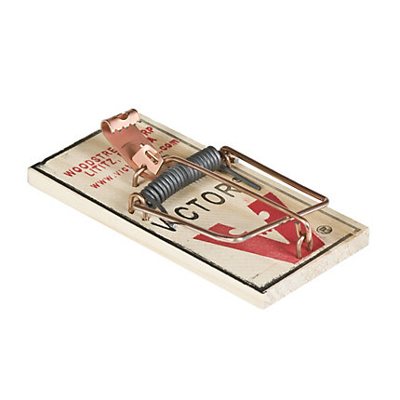**Description:** Students will design and build their own vehicle which must be solely powered by a standard mousetrap and have the fastest elapsed time over a 5-meter track. Additionally, vehicles will ascend a 30˚ Power Ramp. Kits are not allowed. Project must be the original work of the student(s). Judges may ask quest ions to verify.

This event is designed to encourage students to develop engineering skills by designing, testing, and iterating a Mousetrap Car*. This event is not part of a national competition,* so students are not required to prepare a technical papers or posters, nor will they participate in any oral interviews or presentations.

**Materials:** One standard-sized, single spring “Victor” mousetrap is required; All other materials to build the vehicle are legal and optional.

**Team Members:** All members of your team must be active MESA club members. Each team must consist of between 2 and 4 MESA club members.

**Engineering Design Notebook:** Each team should use an Engineering Design Notebook as they construct their device. The notebooks are for the students use, so students will not submit their notebooks. The following design notebook templates may help students document their progress.

* <http://bit.ly/suutemplate>
* <http://bit.ly/plumesatemplate>
* <http://bit.ly/azmesatemplate>
* <http://bit.ly/gadoetemplate>
* <http://bit.ly/odetemplate>

**General Rules:**

1. Students must design and build their own vehicle which must be solely powered by the mousetrap and activated by tripping the original mousetrap trip mechanism
2. No other energy source may be added. (e.g.CO2 Cartridge, batteries, elastic strings, rubber bands, etc.)
3. The standard mousetrap must be mounted to the chassis AND must NOT be painted or decorated.
4. Hardware may be added to the mousetrap, but the original hardware and mounting block may ONLY be altered to attach it to the vehicle. The mousetrap may not be disassembled and then reassembled.
5. The springs on the mousetrap may NOT be cut, bent, over-wound, heat-treated or altered in any other manner.
6. No part of the vehicle may be attached to any part of the track. The track may not be altered in any way.
7. Vehicle must roll or coast along the track. All wheels must stay in contact with the surface of the track.
8. Car must be clearly labeled with the students’ names and the school name.

**Speed & Distance Track:**

1. At Physics Day, the area will be a concrete surface. The joints will be covered with poster board and duct tape to create the smoothest possible surface.
2. The track will follow these specifications:



**Power Ramp:**

1. The track will be set at about a 30˚ angle. It will be 4 feet wide and either 8 or 12 feet long, following these specifications:.



**Judging**

1. Vehicles will be checked for specifications prior to the performance event.
2. Vehicles will not be weighted this year. Weight will not be used as part of the overall score.
3. Each vehicle will be allowed 2 runs on the Speed and Distance Track and two runs on the Power Ramp.
4. Each vehicle must be ready for competition when called or forfeit that trial.
5. Each vehicle must be in a “ready, stationary, hands-off” position prior to the start. Ready Position: Vehicle resting with front wheels within the “start zone”.
6. One team member will be responsible for launch and will indicate to the judge that the vehicle is in the ready position.
7. Students may not touch or interfere with the vehicle once the lever has been tripped.
8. ***Speed & Distance Event:*** 
   1. The team member must wait until the judge gives the “START” order. If the vehicle moves prior to this, a “False Start” will be declared by the judges.
   2. Only one “False Start” will be allowed per run. Two “False Starts” during a run attempt disqualifies that run.
   3. Time will begin when judge calls “Start” and will end when the front wheel(s) of the vehicle cross the finish line.
   4. Time will begin when judge calls “Start” and will end when the front wheel(s) of the vehicle cross the finish line.
   5. It is suggested that timers start at the “start line” of the track and move with the car to ensure watches are stopped when the car crosses the finish line.
   6. After the vehicle crosses the finish line it will be allowed to roll until it runs out of energy. At that point distance will be measured from the starting line to the back of the vehicle.
   7. Vehicles that cross out of the masking tape track before crossing the finish line will be disqualified from the run. Students should build cars that drive as straight as possible.
   8. If a vehicle crosses out of the masking tape track after crossing the finish line, the distance will be calculated by measuring from the starting line to the point where the vehicle crossed out of the track.
9. ***Power Ramp:*** 
   1. The judges will determine how far up the ramp the car climbs.
   2. Distance will be calculated to the back of the vehicle.
   3. This event will not be timed.
10. ***Scoring:*** 
    1. An overall score for each team will be generated using an Excel spreadsheet.
    2. Speed will account for 33% of the overall score.
    3. Distance will account for 33% of the overall score.
    4. Power Ramp will account for 34% of the overall score.
    5. Vehicle weight will have no bearing on the overall score.

**Notes:**

* USU Physics Day is held at Lagoon on a Friday in late May.
* The most successful teams will build their vehicles early so that they have plenty of time to test and adjust the designs.
* All judges’ decisions are final.
* ***These rules may be updated or amended until April 5, 2019.***Check this website for the latest version of the rules: <https://mesaut.org/physics-day/>
* Keep in mind, that the purpose of this contest is to use creativity to build the best mousetrap car within the framework of the rules. The purpose is not to break the rules and see if you can get away with it.
* ***Students wishing to qualify for the MESA USA Engineering Competition in Arizona, must compete in the MESA Utah Arduino Solutions Competition (which will be held on a Saturday in April).*** *Students may choose to compete in both competitions. Students may also compete in the MESA Arduino Race at USU Physics Day. For information about the National Engineering Design Competition:* [*https://mesaut.org/resources/nationalcompetition/*](https://mesaut.org/resources/nationalcompetition/)