Launch Log
Grids and Games
Second Grade

Name:

__________________________________________________________________

Table of Contents

Page | Title | Date
1 | Activity 1: Repeating Rosie
5 | Activity 2: Moving With Math
11 | Activity 3: Computer Science Explorers
17 | Project: Sweep the Grid
23 | Problem: Game Makers

Activity 1: Repeating Rosie
Thinking Questions
What is the problem that Mylo, Suzie, and Angelina have in this story?
____________________________________________________________________
____________________________________________________________________

What is a program?
____________________________________________________________________

What is a code?
____________________________________________________________________

How can you resolve conflicts with your group?
__________________________________________________________________________________________________________________________________________

What is a “bug” in a program?
_____________________________________________________________________

Draw a picture of your group giving Rosie instructions.

Activity 1: Repeating Rosie

Directions: Rosie will follow the program shown in the code cards to solve the maze below. There are three places where Rosie could use a loop to repeat a step more than once. Can you find where those places are? The first set of repeating cards is circled for you as an example. Find two more places where the cards repeat and circle the cards.
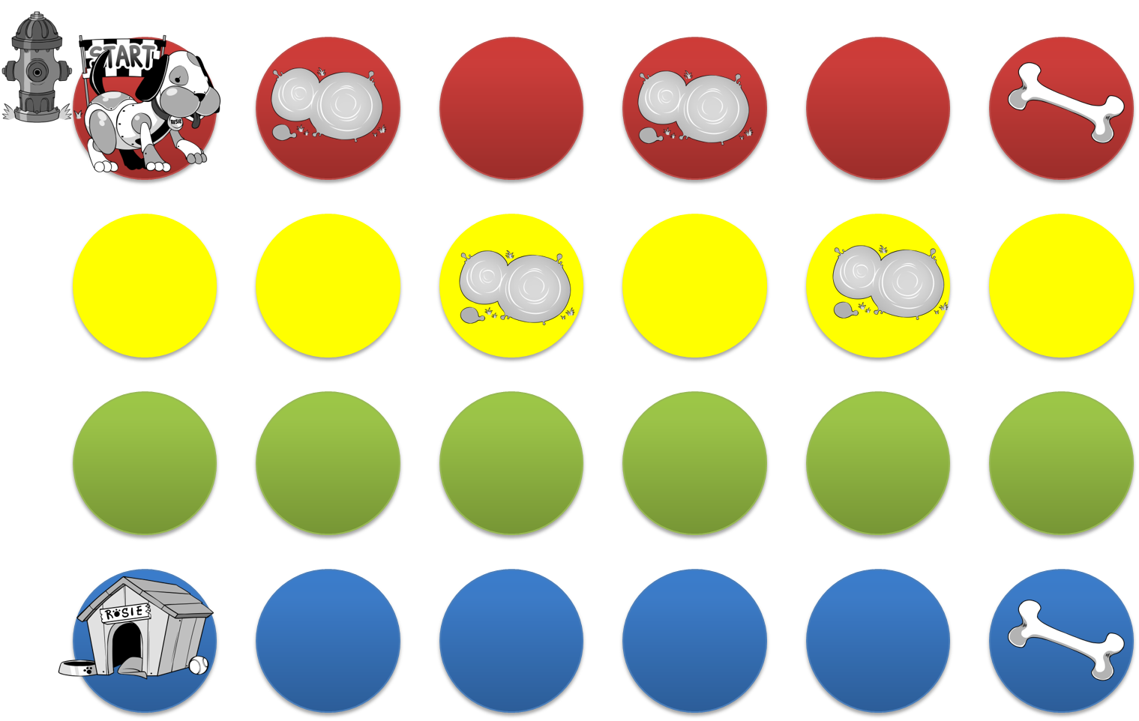

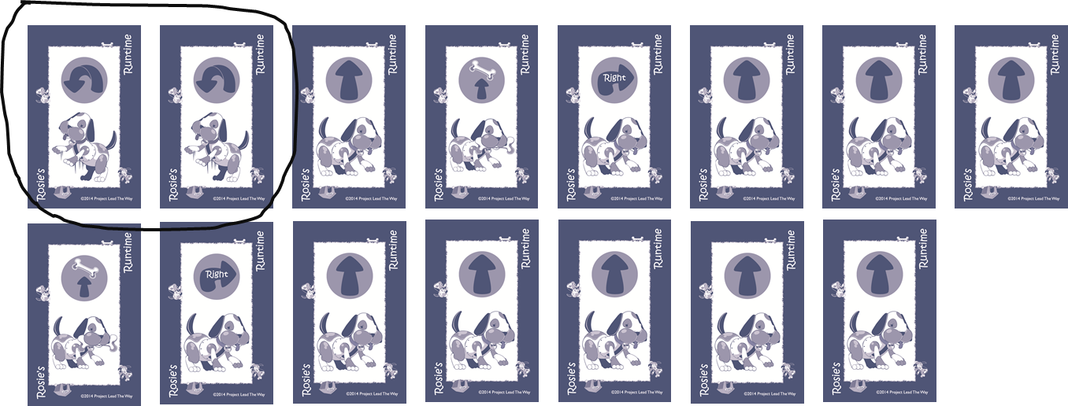

The program shown here is the same as the program on the previous page except that some cards have been replaced with loops. Draw lines from the numbered repeat folders to the correct place in the program for each one.
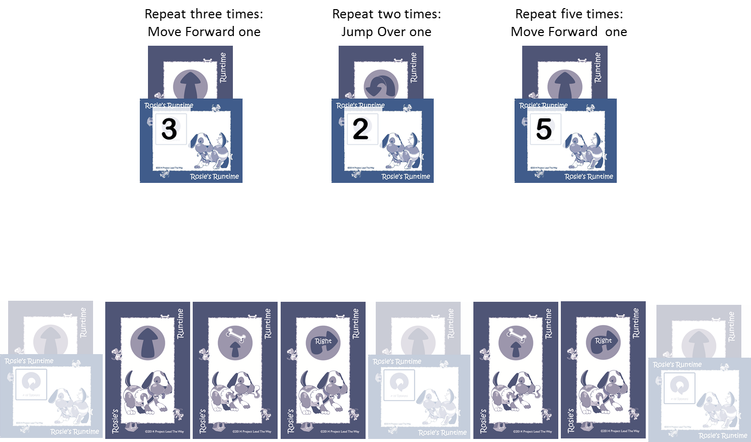

Conclusion Questions

- Were there times when Rosie did something that the programmers did not plan for her to do? Why does Rosie do exactly what she is told?
__________________________________________________________________
__________________________________________________________________
__________________________________________________________________
__________________________________________________________________

- If you were going to make a computer game for other people to play, what would it be like? What kinds of instructions would the game player be able to give?
__________________________________________________________________
__________________________________________________________________
__________________________________________________________________
__________________________________________________________________
__________________________________________________________________
__________________________________________________________________
__________________________________________________________________
__________________________________________________________________
__________________________________________________________________
__________________________________________________________________
Draw a picture of a screen in your game.

Activity 2: Moving With Math: Meet Scratch Jr.

- Which of these programs will make the cat move to the right three steps? Circle Yes or No next to each program.

a. |  | Yes No
b. |  | Yes No
c. |  | Yes No
d. |  | Yes No
e. |  | Yes No

- Read this program carefully.

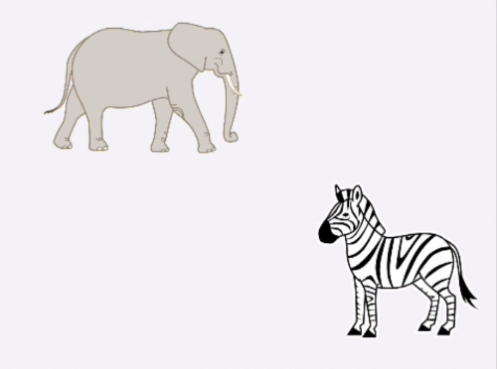 | 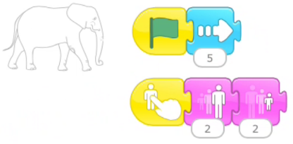
In your own words, explain what happens in this program.

__________________________________________________________________
__________________________________________________________________
__________________________________________________________________
__________________________________________________________________
__________________________________________________________________
__________________________________________________________________
__________________________________________________________________
__________________________________________________________________
Challenge #1: Racing cars to the finish line

- Fill in the boxes with the numbers you used for your cars to move 10 steps to the finish line.

- Fill in the boxes with another example that you could have used to make the cars move the same distance.

- Explain what will happen if you make the cars go a total of 20 steps instead. Try it out and see.

__________________________________________________________________
__________________________________________________________________
__________________________________________________________________
__________________________________________________________________
__________________________________________________________________
Challenge #2: Getting animals to the barn
- What was the original position of the pig?

Row ________ Column ________

- What was the original position of the barn?

Row ________ Column ________

- How many steps did the pig move up to get to the same row as the barn? ________

- How many steps did the pig move right to get to the same column as the barn? ________

- Which of these programs will make the pig get to the barn? Circle Yes or No for each program.

a. |  | Yes No
b. |  | Yes No
c. |  | Yes No
Challenge #3: Numbers and loops

Fill in the Ending Column numbers for each case below.

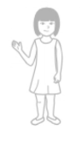 | Starting Column Number of Taps Ending Column  5 1  5 2  5 3  5 4

Starting Column | Number of Taps | Ending Column
2 | 1
2 | 2
2 | 3
2 | 4
2 | 8
2 | 10

Conclusion Questions
- As you noticed in challenge #3, you can use a repeat loop to make the boy and the girl move a total of 10 steps each, even though their programs are different. Can you think of other examples of two different programs that would move characters the same number of steps?

- Recall that Angelina wanted to create a game on her tablet using Scratch Jr. Can you think of ways that you can use what you have learned in this activity to help you make a game?
__________________________________________________________________
__________________________________________________________________
__________________________________________________________________
__________________________________________________________________
__________________________________________________________________
- How can “pair programming” help Angelina make her game?
________________________________________________________________________________________________________________________________________________________________________________________________________________________________________________________________________________________________________
Activity 3: Computer Science Explorers

Part 1 What Is Computer Science?
- Use this section to write down ideas when you brainstorm about Computer Science with your partner.

- What are two things you learned from reading “Computer Science Is Everywhere”? Write them below.
__________________________________________________________________
__________________________________________________________________
__________________________________________________________________
__________________________________________________________________
__________________________________________________________________
__________________________________________________________________
Part 2: Scratch Jr. Scorekeeper Project Planner
As you follow the steps to create the Scorekeeper project, fill in the planner below.

- Draw a picture of the game board with two soccer goals and one soccer ball.

Team 1 Color: ___________________________________________________

Team 2 Color: ____________________________________________

- Programming the soccer ball to respond to the team arrow buttons.
The picture below shows a program for a frog and programs for two arrows. Notice how the arrows send messages to the frog. Use this example to help you fill in the planner for the arrows you will program for the Scorekeeper.
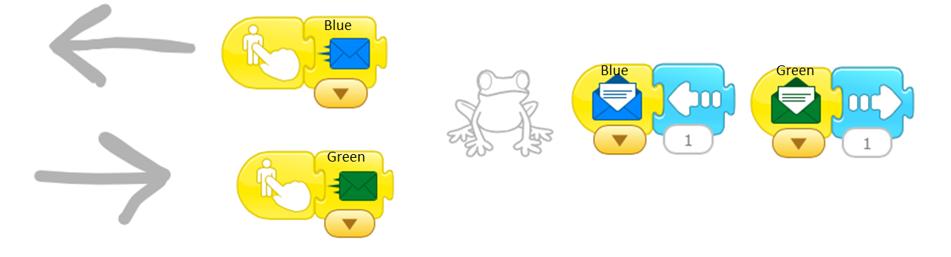

Plan a program for Team 1’s arrow:
When team 1 gets a point, they tap the left arrow. Which color message will you use to send a Move Left message to the ball? Sketch the blocks for team 1’s arrow below.

Plan a program for Team 2’s arrow:
When team 2 gets a point, they tap the right arrow. Which color message will you use to send a Move Right message to the ball? Sketch the blocks for team 2’s arrow below.
Plan a program for the soccer ball:
When the soccer ball receives a message from team 1’s arrow, it should move to the left. When it receives a message from team 2’s arrow, it should move to the right. Fill in the spaces below to describe the program for the soccer ball.

When Soccer Ball receives a ________ message, Move ________ 1 square.
When Soccer Ball receives a _________message, Move ________ 1 square.

- Set the starting positions for the characters.
Make sure that the soccer ball is the same distance from goal 1 as it is from goal 2.
Record the starting positions below so that you can reset them to their starting places after playing the game.
Character | Starting X number (bottom) | Starting Y number (side)
Goal 1
Soccer Ball
Goal 2

How many squares are between the ball and goal 1? ___________________

How many squares are between the ball and goal 2? ___________________

Conclusion Questions
- When you programmed your scorekeeper project, how did you make sure that the ball and the two goals were lined up properly so that each team had the same number of steps to reach their goal?
__________________________________________________________________
__________________________________________________________________
__________________________________________________________________
__________________________________________________________________

Write the math equations or draw a number line to show how you figured this out.

- Think of a job that you might like to have when you are grown up. Write down what your job would be and some of the things you would do in that job. Would your job be easier if you could use computers to help you? Explain.
__________________________________________________________________
__________________________________________________________________
__________________________________________________________________
__________________________________________________________________
__________________________________________________________________
Draw a picture of you as a grown-up doing that job.

Project: Sweep the Grid

Design a Sweep the Grid Algorithm
Use the engineering design process to build a Scratch Jr. project that makes a character move over every square on the grid.

- Ask: What is the problem?
Write down the problem in your own words.

__________________________________________________________________
__________________________________________________________________
__________________________________________________________________
__________________________________________________________________
__________________________________________________________________
__________________________________________________________________
__________________________________________________________________

- Explore: What are the ways to solve this problem?
In the two grids on the next page, draw a path that a character could take to sweep over every square on the grid. Start in square one and draw lines and arrows to show the direction that the character is moving. Write a different path in each of the grids.
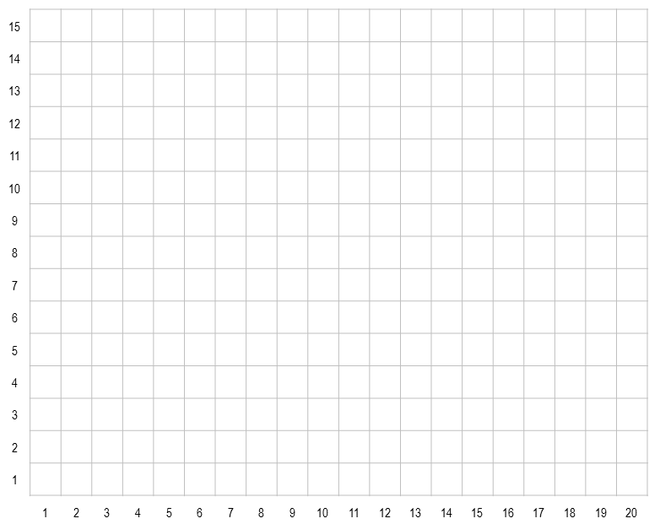

- Model: Create a solution for the problem.
Choose one of the paths from the Explore step above. The first step in building a computer program is to write an algorithm. An algorithm is like a recipe. It is a list of steps that say how to complete a task. Answer the questions below to figure out the steps in the algorithm that will direct the character along the path. Write the steps in the spaces using words and pictures.
Step 1. The character starts on square ________________________________.

Step 2.

Step 3.

Step 4.

Step 5.

If you need to list more steps, use the space below.

Build: Once you are happy with your plan, go into Scratch Jr. and turn each step of your algorithm into blocks that tell your character what to do.

- Evaluate: Test to see if the solution solves the problem.
When you tested your program, did it do what you wanted? Yes No
Were there any problems that you had to fix? If so, describe them here.

__________________________________________________________________
__________________________________________________________________
__________________________________________________________________
__________________________________________________________________
- Explain: Talk about how and why your solution works.
Does your solution use a loop? Yes No
How many loops does your program use? ______________
Sketch how your character sweeps the grid. You can do this by drawing the blocks or using words to describe how the character moves over the grid.
Conclusion Questions

- What is the difference between an algorithm and a program? Which one can a computer understand?
__________________________________________________________________
__________________________________________________________________
__________________________________________________________________
__________________________________________________________________

- Loops are very useful in computer programming. Can you think of another way to use a loop to make a character move around on the grid? Describe a loop that you could use to animate a character in Scratch Jr. It does not have to be a grid sweeper that touches every square. Your loop could make the character move diagonally or some other way. Write a short algorithm for moving a character that includes at least one loop.

__________________________________________________________________
__________________________________________________________________
__________________________________________________________________
__________________________________________________________________
__________________________________________________________________
Problem: Game Makers
Use the engineering design process to create a game in Scratch Jr.

Ask: What is the problem?
Fill in the blanks below to complete the description of the game requirements.
- The game should have _____ main character.
- The game should have two _______________ that make the main character move.
- The game should have a _______________ that the main character has to reach in order to win the game.
- The game should have an obstacle character. If the main character hits the obstacle, then the player _______________.

Reflection
Design Process Step 1: Ask
- I can explain the design problem.
- I can find information that I need to solve the problem.
Teacher Notes

Explore: Use this graphic organizer to set up the game you want to build.
- The main character in my game is:

- The obstacle in my game is:

- The target in my game is:

- Draw a sketch of the three screens of the game.
The Main Screen
The Losing Screen
The Winning Screen
Reflection
Design Process Step 2: Explore
- I can brainstorm ideas of how to solve the problem.
- I can research to find out about ways to solve the problem.
Teacher Notes

Model: Turn your game idea into a program. The first step in building a computer program is to write an algorithm. An algorithm is like a recipe. It is a list of steps for completing a task. Answer the questions below to figure out the steps in your algorithm.

Algorithm for Target
Write down the steps for the target character. Where will the target be located on the screen? Will it move? What should happen when the main character bumps into the target?
When the game starts the target character _____________________________________________
_____________________________________________________________________________________________
When the main character bumps into the target _________________________________________
_____________________________________________________________________________________________
Algorithm for Obstacle
Write down the steps for the obstacle character. What will the obstacle character do when the game starts? Will it move? What should happen when the main character bumps into the obstacle?
When the game starts the obstacle character ___________________________________________
_____________________________________________________________________________________________
When the main character bumps into the obstacle _______________________________________
____________________________________________________________________________________________
Algorithm for Main Character
Write down the steps for the main character. What will the main character do when the game starts? How will the main character be controlled by the player?
When the game starts the main character _______________________________________________
_______________________________________________________________________________
The main character moves _________________________________________________________ when ____________________________________________________________________________________________
Build your Program in Scratch Jr. using Code Blocks
Use what you have written above to take each step from your algorithm and turn it into a program using code blocks that tell the characters what to do.

Reflection
Design Process Step 3: Model
- I designed an algorithm that solves the design problem and meets all of the requirements.
- I turned my algorithm into a working program.
Teacher Notes

Evaluate: Did my design meet all of the design requirements?

- My game has a main character that is controlled by arrows.
- My game has an obstacle character.
- The player loses when the main character bumps into the obstacle. Then the game ends.
- The player wins when the main character bumps into the target. Then the game ends.
Explain one thing you did well and one thing you would like to do better in this project.
__________________________________________________________________
__________________________________________________________________
__________________________________________________________________
__________________________________________________________________
Reflection
Design Process Step 4: Evaluate
- I can explain the strengths and weaknesses of my model.
- I can compare how my program performed with other programs.
Teacher Notes

Explain: Did your program solve the problem? Why or why not?

__________________________________________________________________
__________________________________________________________________
__________________________________________________________________
__________________________________________________________________
__________________________________________________________________
__________________________________________________________________

Reflection
Design Process Step 5: Explain
- I can explain how my program works and how it solved (or did not solve) the problem.
- I can suggest ways to improve my design.
- I can predict how my improvements will solve the problem.
Teacher Notes

Conclusion Questions

- What is the difference between a Repeat Forever loop and a Repeat loop that has a set number of repeats?
__________________________________________________________________
__________________________________________________________________
__________________________________________________________________
__________________________________________________________________

- Do you think video games use loops? Give an example of a game that you have played that has some type of repeating steps in it. This can be a physical game like you play at school or a video game that you have played on a TV or handheld game device.
__________________________________________________________________
__________________________________________________________________
__________________________________________________________________
__________________________________________________________________
__________________________________________________________________
__________________________________________________________________
Essential Questions
- How can I use digital tools to express my thoughts and ideas?

_______________________________________________________________________________

_______________________________________________________________________________

_______________________________________________________________________________

_______________________________________________________________________________

- How do humans use computers to solve problems?

_______________________________________________________________________________

_______________________________________________________________________________

_______________________________________________________________________________

_______________________________________________________________________________

Draw a picture of your favorite part of learning how to program computers.

