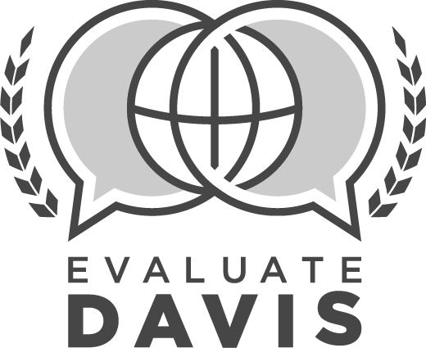
COUNSELOR
SUMMATIVE EVALUATION

Counselor: |  |  | Assignment:
Employee ID #: |  |  | Date:
School: |  |  | School Year:

SUMMATIVE EVALUATION PRE-CONFERENCE
To be completed before employee conference
1 | Review of observation data  No  Yes |  | Optional Comments:
2 | Review of survey data  No  Yes |  | Optional Comments:
3 | Review of applicable student data  No  Yes |  | Optional Comments:
PLAN
4 | (P.1) Creates and implements a vision and goals for counseling in collaboration with school and district administrators
 | Ineffective  Moderately Effective  Effective  Highly Effective |  | Optional Comments:
5 | (P.2) Analyzes and uses ongoing data to create programs and activities that meet the individual needs of all students
 | Ineffective  Moderately Effective  Effective  Highly Effective |  | Optional Comments:
6 | (P.3) Designs guidance curriculum aligned with content standards identified in the Utah Model Comprehensive Counseling and Guidance Program and DESK
 | Ineffective  Moderately Effective  Effective  Highly Effective |  | Optional Comments:
7 | (P.4) Plans, prioritizes, and balances work tasks to devote a majority of time to direct services to students
 | Ineffective  Moderately Effective  Effective  Highly Effective |  | Optional Comments:
8 | (P.5) Ensures services are available to address identified needs, immediate concerns, and crises
 | Ineffective  Moderately Effective  Effective  Highly Effective |  | Optional Comments:
TEACH & GUIDE
9 | (T.1) Partners with classroom teachers to plan and deliver curriculum based on the needs of the students
 | Ineffective  Moderately Effective  Effective  Highly Effective |  | Optional Comments:
10 | (T.2) Facilitates personal development and college/career readiness for all students in a variety of venues including large group, small group, and one on one
 | Ineffective  Moderately Effective  Effective  Highly Effective |  | Optional Comments:
11 | (T.3) Proactively acquires and provides information and resources in multiple ways based on individual student and school community needs
 | Ineffective  Moderately Effective  Effective  Highly Effective |  | Optional Comments:
12 | (T.4) Engages learners through effective instructional strategies
 | Ineffective  Moderately Effective  Effective  Highly Effective |  | Optional Comments:
CHECK
13 | (C.1) Implements follow-up procedures and uses feedback to make adjustments to guidance curriculum, resources, or support
 | Ineffective  Moderately Effective  Effective  Highly Effective |  | Optional Comments:
14 | (C.2) Tracks student progress and provides specific, timely, and ongoing information to students and parents
 | Ineffective  Moderately Effective  Effective  Highly Effective |  | Optional Comments:
15 | (C.3) Collects a variety of data to assess student, school, and community needs
 | Ineffective  Moderately Effective  Effective  Highly Effective |  | Optional Comments:
ENVIRONMENT
16 | (E.1) Fosters a safe environment where counselors, staff, and students are positive and respectful
 | Ineffective  Moderately Effective  Effective  Highly Effective |  | Optional Comments:
17 | (E.2) Knows students as individuals and responds to their diverse needs
 | Ineffective  Moderately Effective  Effective  Highly Effective |  | Optional Comments:
18 | (E.3) Demonstrates caring and understanding within an environment of high expectations
 | Ineffective  Moderately Effective  Effective  Highly Effective |  | Optional Comments:
19 | (E.4) Creates an inviting and productive environment through effective organization
 | Ineffective  Moderately Effective  Effective  Highly Effective |  | Optional Comments:
PROFESSIONALISM
20 | (PRO.1) Engages in self-reflection and professional learning for continuous growth and expertise
 | Ineffective  Moderately Effective  Effective  Highly Effective |  | Optional Comments:
21 | (PRO.2) Collaborates and cultivates productive relationships with staff, students, parents, administrators, and community to improve learning
 | Ineffective  Moderately Effective  Effective  Highly Effective |  | Optional Comments:
22 | (PRO.3) Approaches challenges and changes positively in a problem-solving manner
 | Ineffective  Moderately Effective  Effective  Highly Effective |  | Optional Comments:
23 | Adheres to all school, district, and state policies and procedures with consistency.
 | No (comments required)  Yes (comments optional) |  | Comments:
24 | Commendations, Recommendations, Other:
SUMMATIVE EVALUATION CONFERENCE
To be completed with employee
PROFESSIONAL GROWTH PLAN:
25 | Educator has reviewed stakeholder feedback, and has responded by making adjustments as needed.
 | Did not review  Reviewed, but did not make adjustments to practice  Reviewed, and made adjustments to practice  Reviewed, scores indicated changes were not needed |  | Optional Comments:
26 | Professional Development Review  Complete |  | Optional Comments:
27 | Professional Contributions (please list)  Complete |  | List:
28 | (PRO.4) Makes professional contributions to school, district, and school community
 | Ineffective  Moderately Effective  Effective  Highly Effective |  | Optional Comments:
REVIEW OF GOALS
Performance Goal #1 |  | No progress toward goal | Progress made toward goal | Met goal
Academic Goal #2 |  | No progress toward goal | Progress made toward goal | Met goal
Academic Goal #3 |  | No progress toward goal | Progress made toward goal | Met goal

Counselor Signature | Date |  | Supervisor Signature | Date

