A Princess has a schedule at school.

When a Princess forgets what to do, she looks at her schedule.

I have a schedule. I can look at my schedule just like a Princess.

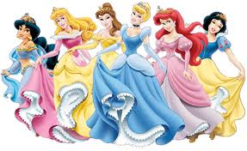

My friends from Star Wars tell me that sometimes there are changes or there may be a surprise.

That’s OK!

Yoda says changes are ok.

“OK changes are.”

Surprises are ok too.

“OK surprises are.”

