MESA ARDUINO CAR RACE 2019
A State MESA Competition at USU Physics Day at Lagoon

Event Registration: https://www.surveymonkey.com/r/mesaarduinocar19
All registrations are due by Friday, May 10, 2019.
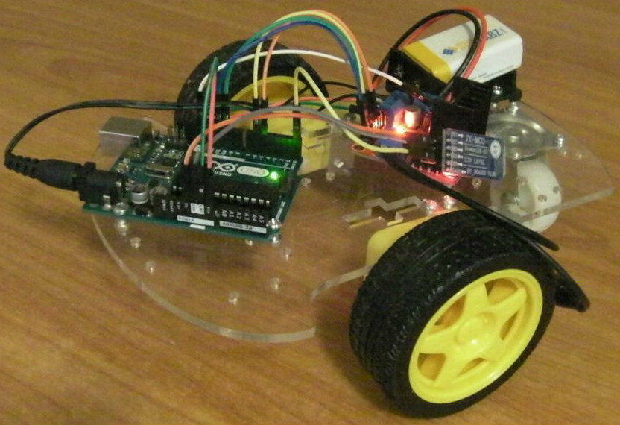
Description: As a team, you will build your own Arduino controlled vehicle. Then you will race the vehicles around a track. Cars may be controlled remotely by a wireless signal, by a tethered remote, or autonomously. A black line will be taped or drawn onto the track to facilitate autonomous vehicles. Your team must build or assemble your own car. You may buy the components separately and design a custom vehicle or you may use a kit. Arduino code may be original or it may be code that was retrieved from an outside source.
This event is designed to encourage students to experiment with basic electronics and coding. This event is not part of a national competition, so students are not required to prepare a technical papers or posters nor will they participate in any oral interviews or presentations.
The MESA Arduino Car is meant to be an easier competition because students do not need to create an original design. Kits can be purchased and there are various Arduino car and robot tutorials available online.
Track Details: The specific details of the track’s shape and length have not yet been determined. Look for an update by January. The competition will be held on a concrete surface under a pavilion at Lagoon. Joints in the concrete surface will be covered with white poster board and white duct tape to make the surface as smooth as possible. Teams may not touch their vehicles during the race. Touching the vehicle during the race will result in an automatic disqualification.

Materials: The vehicle must use an Arduino (or Arduino compatible board) and must drive on at least two wheels. The total cost of the vehicle may not exceed $65 for all components including batteries. If an Android device is used to control the car, the price of the Android device may be excluded from the budget. Students must determine a fair price for any free items by searching for how much the items cost online.
Your team must provide a budget sheet listing the cost of each component and the total cost of the vehicle. All components including components acquired for free must be included in the budget sheet We will be using the honor system instead of checking individual receipts. Keep in mind, that the purpose of this contest is to use creativity to build the best Arduino Race Car within the framework of the rules. The purpose is not to break the rules and see if you can get away with it.
Team Members: All members of your team must be active MESA club members. Each team must consist of between 2 and 4 MESA club members.
Engineering Design Notebook: Each team should use an Engineering Design Notebook. The notebooks are for the students use, so students will not submit their notebooks. The following design notebook templates may help students document their progress.
- http://bit.ly/suutemplate
- http://bit.ly/plumesatemplate
- http://bit.ly/azmesatemplate
- http://bit.ly/gadoetemplate
- http://bit.ly/odetemplate
Notes:
- USU Physics Day is held at Lagoon on a Friday in late May.
- The most successful teams will build their vehicles early so that they have plenty of time to test, adjust the design, and practice driving.
- All judges’ decisions are final.
- These rules may be updated or amended until April 5, 2019. Check this website for the latest version of the rules: https://mesaut.org/physics-day/
- Students wishing to qualify for the MESA USA Engineering Competition in Arizona, must compete in the MESA Utah Arduino Solutions Competition (which will be held on a Saturday in April). Students may choose to compete in both competitions. Students may also compete in the MESA Mousetrap Car Competition at USU Physics Day. For information about the National Engineering Design Competition: https://mesaut.org/resources/nationalcompetition/

