(Current Date)
Dear (SCHOOL) Parents and Students:
School attendance has a huge impact on a student’s academic success… starting in kindergarten and continuing through high school.
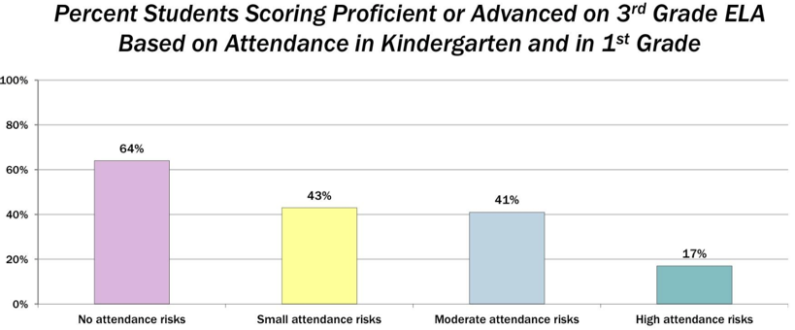
We realize some absences are unavoidable due to health problems or other circumstances. We also know that when students miss too much school— regardless of the reason – it can cause them to fall behind academically. Your child is less likely to succeed if he or she is chronically absent or late.
Research shows:
- Children chronically absent or tardy in kindergarten and 1st grade are much less likely to read at grade level by the end of 3rd grade.

- By 6th grade, chronic absences or tardiness are a proven early warning sign for students at risk for dropping out of school.
Source: Attendanceworks.org

- A child is chronically absent if he or she misses just two days every month!

Some considerations that will help ensure that your child attends school regularly and on time are:

Ensure your children go to school every day unless they are truly sick.
- routine.

Lay out clothes and pack backpacks the night before.
Make sure your children keep a regular bedtime and establish a morning routine.

Develop back up plans for a way to school if something comes up. Call a family member, neighbor, or another parent to take your child to school.
Talk to teachers, counselors, or administrators for advice if your children feel anxious about going to school.
.
routine.

Avoid scheduling vacations or doctor appointments when school is in session.

Let us know how we can continue to partner with you in behalf of your children so they can be successful in school! If you have any questions or need more information, please contact your elementary school.

Sincerely,
(School Name) Administration Team

