Launch Log:

Input/Output:
Computer Systems
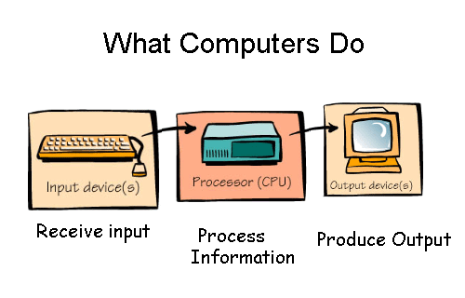

Name __________________

Table Of Contents
Page | Date | Title
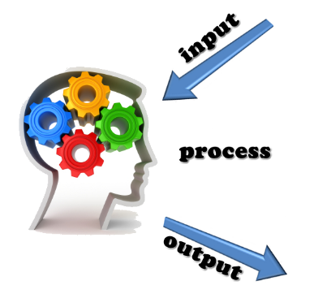

Activity 1
What is the problem in the story?
____________________________________________________________________________________________________________________________________________________________________________________
What do you need to know to be able to design a solution to the problem?
____________________________________________________________________________________________________________________________________________________________________________________________________________________________________________________________

What skills will be needed to solve the problem?
____________________________________________________________________________________________________________________________________________________________________________________________________________________________________________________________

Computer Anatomy Video
Observations | Questions

Understanding_________________________________________________________________________________________________________________________________________________________________________________________________________________________________________________________________________________________________________________________________________________________________

Sketch a machine that has at least one input and one output.

Pass The Input Data
Input Type | Signal Travel Time
Shoulder Trial 1

Shoulder Trial 2

Shoulder Trial 3

Ankle Trial 1

Ankle Trial 2

Ankle Trial 3

Shoulder Travel Time Average Ankle Travel Time Average

Observations:
______________________________________________________________________________________________________________________________________________________________________________________________________________________________________________________________________________________________________________________________________________________________________________________________________________
Activity 1 Conclusion Questions:
- Why did it take different amounts of time to pass a signal through shoulders than to pass a signal through ankles?
______________________________________________________________________________________________________________________________________________________________________________________________________________________________________________________________________________________________________________________________________________________________________________________________________________________________________________________________________________________________________________________________________________________________________________________________________________________________________________________

- Draw an outline of a person’s body. Label the two body parts where the input entered the body during this game. Label the part of the body that processed the information that the input gave. Label the part of the body that produced output.

Activity 2 : Part 1
Input ____________________________________________________________
Output: __________________________________________________________________________________________________
Bit ______________________________________________________________
Byte _____________________________________________________________
ASCII ____________________________________________________________
Pixel _____________________________________________________________
Abstraction _________________________________________________________
Collaborate: _________________________________________________________

Activity 2 : Part 2 Internet Safety
Take notes below during a class discussion on internet safety.

Activity 2 Conclusion Questions
- What are two examples of things you could do with a computer that are not safe?
____________________________________________________________________________________________________________________________________________________________________________________________________________________________________________

- When you create an image on graph paper to be encoded for transmission, could you color in half of a square? Explain your answer.
_______________________________________________________________________________________________________________________________________________________________________________________________________________________________________________________________________________________________________
- It took you some time to encode a picture into numbers and it took your partner some time to decode the picture and recreate it. Why do you think encoding and decoding is a slow process for humans but a very quick process for computers?
____________________________________________________________________________________________________________________________________________________________________________________________________________________________________________

Activity 3

Program ____________________________________________________________________
Sequence ____________________________________________________________________
Variables ____________________________________________________________________
Functions ____________________________________________________________________
Code _______________________________________________________________________
Activity 3: Procedure Steps 1 -2
Data Observations:

Activity 3 Conclusion Questions
- Use a ruler to draw an x-y grid similar to the one in Tynker. Let the x and y axes range from -5 to 5. Add a dot on the grid to represent an actor. Describe how you can control the position of that dot in Tynker using the x- and y- coordinates. Write the Tynker block names to show your understanding.

- Think of a video game you have seen or played before.
- What variables might the programmer have used when programming that game?

- What events/triggers could the programmer have had to use to make the game work?

Project : Reaction Test
Test ______________________________________________________________
Solution ___________________________________________________________
Design Process ______________________________________________________
Bugs _____________________________________________________________
Debugging _________________________________________________________

Procedures:
Ask:
- What is the game?

- What are the requirements?

Explore:

*** You WILL complete the optional challenge: Hit or Miss Game ***
Project Conclusion Questions:
- If you were asked to make an advanced level of this game you could make the actor appear for a shorter amount of time, making it even harder for the player to tap it before it disappears. What change would you make to your code to make the actor disappear more quickly?

- During this game both the human brain and the computer are receiving input, processing information, and producing output. In the chart below identify what the player’s brain is receiving as input, what it is processing, and what it is putting out during the game. Also identify what the computer is receiving as input, what it is processing, and what its output is during the game.

System | Input | Processing | Output
Human Brain

Computer

- What are other ways that computers are used to help humans diagnose injuries?
____________________________________________________________________________________________________________________________________________________________________________________________________________________________________________

Problem: Brain Fitness
After watching the Design Process Video, complete the following steps of the design process.
Ask:
- What is the need or want that you are trying to fulfull?

- What will make the solution successful? (Hint: criteria)

- What constraints will impact the solution?

Explore:
Follow step 6 of your procedures.

Model:
Follow step 7 of your procedures.

Evaluate:
Follow step 8 of your procedures.

Explain:
Follow step 9 of your procedures.

Problem Conclusion Questions:
- While building the solution, you had to make sure you were meeting the design criteria. Explain why it is helpful to know the requirements of a project before you start working on it.

- When you identified smaller problems to solve, what did you discover that could be accomplished with a loop or a conditional? Describe one loop or conditional in your solution.

