Suicide and Crisis Lifeline = 988 / Student and Family Resources Department = 801-402-5159
DBH = 801-773-7060 / SAFEUT = 833-372-3388 or safeut.org / Crisis Text Line in Español AYUDA al 741741
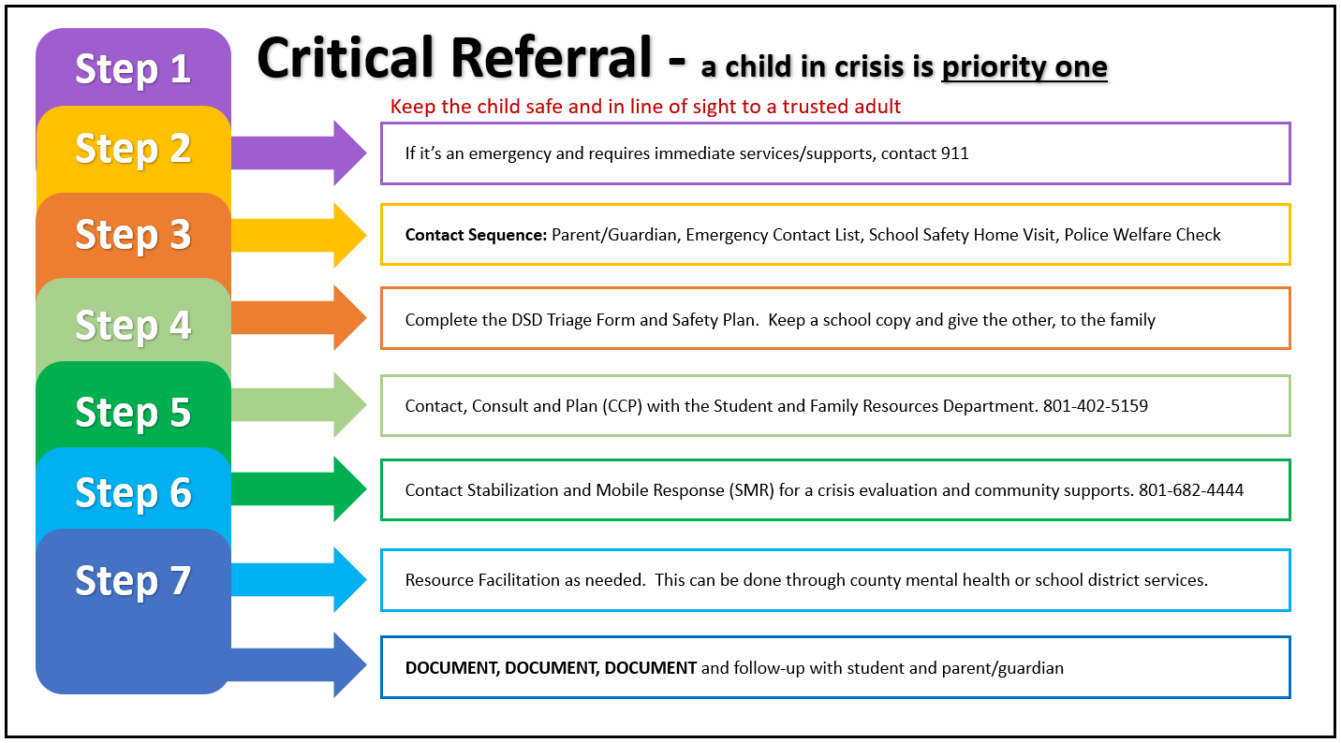
Remember: All roads lead to communicating to parents Consult with your team and district, do not go through the critical situation on your own Document, Document, Document and submit the appropriate reporting forms

