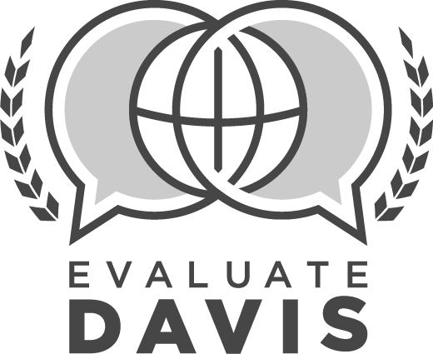
LIBRARIAN
SUMMATIVE EVALUATION

Educator: |  |  | Assignment:
Employee ID #: |  |  | Date:
School: |  |  | School Year:

SUMMATIVE EVALUATION PRE-CONFERENCE
To be completed before employee conference
1 | Review of observation data  No  Yes |  | Optional Comments:
2 | Review of survey data  No  Yes |  | Optional Comments:
3 | Review of applicable student data  No  Yes |  | Optional Comments:
PLAN
4 | (P.1) Proactively participates in the creation of a vision and goals for library services in collaboration with school and district administrators
 | Ineffective  Moderately Effective  Effective  Highly Effective |  | Optional Comments:
5 | (P.2) Designs instruction to meet or exceed DESK standards
 | Ineffective  Moderately Effective  Effective  Highly Effective |  | Optional Comments:
6 | (P.3) Creates and maintains written library policies, guidelines, and procedures for students, staff, and school community
 | Ineffective  Moderately Effective  Effective  Highly Effective |  | Optional Comments:
7 | (P.4) Uses data to plan budgets, programs, activities, and professional development
 | Ineffective  Moderately Effective  Effective  Highly Effective |  | Optional Comments:
8 | (P.5) Selects and maintains a well-developed collection of books and resources to support curriculum and students
 | Ineffective  Moderately Effective  Effective  Highly Effective |  | Optional Comments:
TEACH & TRAIN
9 | (T.1) Partners with classroom teachers to plan and deliver curriculum to meet student needs
 | Ineffective  Moderately Effective  Effective  Highly Effective |  | Optional Comments:
10 | (T.2) Promotes reading as a foundational skill for life-long learning and enjoyment to students, staff, and community
 | Ineffective  Moderately Effective  Effective  Highly Effective |  | Optional Comments:
11 | (T.3) Provides consultation and training in the use of resources and technologies which support curriculum
 | Ineffective  Moderately Effective  Effective  Highly Effective |  | Optional Comments:
12 | (T.4) Engages learners through effective instructional strategies to promote higher level thinking
 | Ineffective  Moderately Effective  Effective  Highly Effective |  | Optional Comments:
13 | (T.5) Provides training, guidance, and support to library assistants and volunteers, as needed
 | Ineffective  Moderately Effective  Effective  Highly Effective |  | Optional Comments:
CHECK
14 | (C.1) Collects a variety of data and feedback to guide library budgets, programs, activities, resources, professional development, and instruction
 | Ineffective  Moderately Effective  Effective  Highly Effective |  | Optional Comments:
15 | (C.2) Consistently evaluates and maintains library resources according to current needs
 | Ineffective  Moderately Effective  Effective  Highly Effective |  | Optional Comments:
16 | (C.3) Meets with administration to evaluate and improve library/media services
 | Ineffective  Moderately Effective  Effective  Highly Effective |  | Optional Comments:
ENVIRONMENT
17 | (E.1) Fosters an environment where librarians, staff, and students are positive and respectful
 | Ineffective  Moderately Effective  Effective  Highly Effective |  | Optional Comments:
18 | (E.2) Demonstrates caring and understanding within an environment of high expectations
 | Ineffective  Moderately Effective  Effective  Highly Effective |  | Optional Comments:
19 | (E.3) Creates an organized, flexible learning environment to facilitate a variety of individual and group activities
 | Ineffective  Moderately Effective  Effective  Highly Effective |  | Optional Comments:
20 | (E.4) Facilitates an environment of support through effective time management, organization, and allocation of resources
 | Ineffective  Moderately Effective  Effective  Highly Effective |  | Optional Comments:
21 | (E.5) Implements library policies and procedures for effective library use
 | Ineffective  Moderately Effective  Effective  Highly Effective |  | Optional Comments:
PROFESSIONALISM
22 | (PRO.1) Engages in self-reflection and professional learning for continuous growth and expertise
 | Ineffective  Moderately Effective  Effective  Highly Effective |  | Optional Comments:
23 | (PRO.2) Collaborates and cultivates productive relationships with staff, students, parents, administrators, and community to improve learning
 | Ineffective  Moderately Effective  Effective  Highly Effective |  | Optional Comments:
24 | (PRO.3) Approaches challenges and changes positively in a problem-solving manner
 | Ineffective  Moderately Effective  Effective  Highly Effective |  | Optional Comments:
25 | Adheres to all school, district, and state policies and procedures with consistency.
 | No (comments required)  Yes (comments optional) |  | Comments:
26 | Commendations, Recommendations, Other:
SUMMATIVE EVALUATION CONFERENCE
To be completed with employee
PROFESSIONAL GROWTH PLAN:
27 | Librarian has reviewed Evaluate Davis survey data, and has responded by making adjustments as needed.
 | Did not review  Reviewed, but did not make adjustments to practice  Reviewed, and made adjustments to practice  Reviewed, scores indicated changes were not needed |  | Optional Comments:
28 | Professional Development Review  Complete |  | Optional Comments:
29 | Professional Contributions (please list)  Complete |  | Comments:
30 | (PRO.4) Makes professional contributions to school, district, and school community
 | Ineffective  Moderately Effective  Effective  Highly Effective |  | Optional Comments:
REVIEW OF GOALS
Performance Goal #1 |  | No progress toward goal | Progress made toward goal | Met goal
Academic Goal #2 |  | No progress toward goal | Progress made toward goal | Met goal
Academic Goal #3 |  | No progress toward goal | Progress made toward goal | Met goal

Librarian Signature | Date |  | Supervisor Signature | Date

