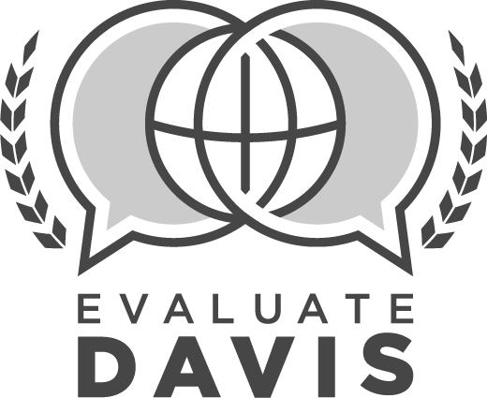
LICENSED DISTRICT EMPLOYEE
SUMMATIVE EVALUATION

Employee: |  |  | Assignment:
Employee ID #: |  |  | Date:
Department: |  |  | School Year:

SUMMATIVE EVALUATION PRE-CONFERENCE
To be completed before employee conference
 | 1 |  | Review of applicable data  Project conference  Presentation/meeting observation  Mid-year conference  Other data (for example, student achievement data, trainings provided, etc.)  Optional Comments:
 | PLAN
 | 2 |  | (P.1) Works collaboratively to plan, develop, and implement district and department mission, vision, and goals
 |  |  | Ineffective  Moderately Effective  Effective  Highly Effective |  | Optional Comments:
 | 3 |  | (P.2) Effectively uses the DSD Planning Process
 |  |  | Ineffective  Moderately Effective  Effective  Highly Effective |  | Optional Comments:
 | 4 |  | (P.3) Plans and organizes to manage work tasks efficiently
 |  |  | Ineffective  Moderately Effective  Effective  Highly Effective |  | Optional Comments:
5 |  | (P.4) Utilizes planning to ensure effective management of district resources
 |  | Ineffective  Moderately Effective  Effective  Highly Effective |  |  | Optional Comments:
 | LEAD, SUPPORT, & TRAIN
 | 6 |  | (L.1) Provides effective and timely leadership, support, training, and/or resources in response to identified needs
 |  |  | Ineffective  Moderately Effective  Effective  Highly Effective |  | Optional Comments:
 | 7 |  | (L.2) Communicates and disseminates information clearly and concisely
 |  |  | Ineffective  Moderately Effective  Effective  Highly Effective |  | Optional Comments:
 | 8 |  | (L.3) Shows initiative in solving problems and undertaking new projects or assignments
 |  |  | Ineffective  Moderately Effective  Effective  Highly Effective |  | Optional Comments:
 | 9 |  | (L.4) Demonstrates effective presentation skills and meeting facilitation
 |  |  | Ineffective  Moderately Effective  Effective  Highly Effective |  | Optional Comments:
 | 10 |  | (L.5) Completes work with accuracy and neatness; tasks, projects, and products are of professional quality
 |  |  | Ineffective  Moderately Effective  Effective  Highly Effective |  | Optional Comments:
 | CHECK
 | 11 |  | (C.1) Seeks feedback and uses data to guide adjustments for continuous improvement
 |  |  | Ineffective  Moderately Effective  Effective  Highly Effective |  | Optional Comments:
 | 12 |  | (C.2) Consistently follows up to ensure stakeholder needs are met and/or problems are resolved
 |  |  | Ineffective  Moderately Effective  Effective  Highly Effective |  | Optional Comments:
 | 13 |  | (C.3) Communicates with supervisor regularly to evaluate performance and project management
 |  |  | Ineffective  Moderately Effective  Effective  Highly Effective |  | Optional Comments:
 | ENVIRONMENT
 | 14 |  | (E.1) Creates a supportive environment by being responsive and accessible
 |  |  | Ineffective  Moderately Effective  Effective  Highly Effective |  | Optional Comments:
 | 15 |  | (E.2) Demonstrates understanding and tact when communicating with stakeholders
 |  |  | Ineffective  Moderately Effective  Effective  Highly Effective |  | Optional Comments:
 | 16 |  | (E.3) Fosters a safe environment where employees are positive, respectful, and understanding of individual differences
 |  |  | Ineffective  Moderately Effective  Effective  Highly Effective |  | Optional Comments:
 | PROFESSIONALISM
 | 17 |  | (PRO.1) Engages in self-reflection and professional learning for continuous growth and expertise
 |  |  | Ineffective  Moderately Effective  Effective  Highly Effective |  | Optional Comments:
 | 18 |  | (PRO.2) Collaborates and cultivates productive relationships with stakeholders to improve learning
 |  |  | Ineffective  Moderately Effective  Effective  Highly Effective |  | Optional Comments:
 | 19 |  | (PRO.3) Approaches challenges and changes in a positive, problem-solving manner
 |  |  | Ineffective  Moderately Effective  Effective  Highly Effective |  | Optional Comments:
20 |  | (PRO.5) Uses the Evaluate Davis system effectively (for LDE who supervises employees)
 |  | Ineffective  Moderately Effective  Effective  Highly Effective |  |  | Optional Comments:
21 |  | (PRO.5.a) Evaluation components completed during appropriate window (for LDE who supervises employees)
 |  | Ineffective  Moderately Effective  Effective  Highly Effective |  |  | Optional Comments:
22 |  | (PRO.5.b) Quality feedback is provided to employees through the evaluation system (for LDE who supervises employees)
 |  | Ineffective  Moderately Effective  Effective  Highly Effective |  |  | Optional Comments:
23 |  | (PRO.5.c) Evidence supports summative ratings of employees (for LDE who supervises employees)
 |  | Ineffective  Moderately Effective  Effective  Highly Effective |  |  | Optional Comments:
24 |  | (PRO.5.d) Follow through is consistently done for employees with “Ineffective” ratings or on “Plan of Assistance” (for LDE who supervises employees)
 |  | Not Applicable  Ineffective  Moderately Effective  Effective  Highly Effective |  |  | Optional Comments:
 | 25 |  | Adheres to all department/school, district, and state policies and procedures with consistency.
 |  |  | No (comments required)  Yes (comments optional) |  | Comments:
 | 26 |  | Commendations, Recommendations, Other:
SUMMATIVE EVALUATION CONFERENCE
To be completed with employee
 | PROFESSIONAL GROWTH PLAN:
 | 27 |  | Professional Development Review  Complete |  | Optional Comments:
 | 28 |  | Professional Contributions (please list)  Complete |  | Comments:
 | 29 |  | (PRO.4) Makes professional contributions to the district, state, and the larger arena of educational policy making
 |  |  | Ineffective  Moderately Effective  Effective  Highly Effective |  | Optional Comments:
 | REVIEW OF GOALS
 | Performance Goal #1 |  |  | No progress toward goal |  | Progress made toward goal | Met goal
 | Academic Goal #2 |  |  | No progress toward goal |  | Progress made toward goal | Met goal
 | Academic Goal |  |  | No progress toward goal |  | Progress made toward goal | Met goal

Employee Signature | Date |  | Supervisor Signature | Date

