The safety and well-being of your student and others on the bus is critical.

A team of individuals, including parents, bus drivers, teachers, and school administrators, can support students in engaging in safe and positive behavior on the bus.

Parents play an important role in establishing behavior expectations, praising good behavior, and correcting behavior issues. Please review the information in this document with your child and coordinating with your child’s principal on any concerns.

Davis School District

Davis School District
Behavior on the Bus
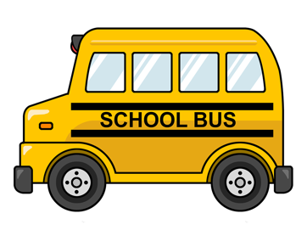

As a school, we want to make sure all students have a safe and positive experience on the bus. This helps set the student up for success throughout the school day and at home.

In order to accomplish this, we want to make sure all students and their parents are aware of expectations for behavior and are aware of how students will be supported.

All Davis School District buses have a set of rules for expected behavior:

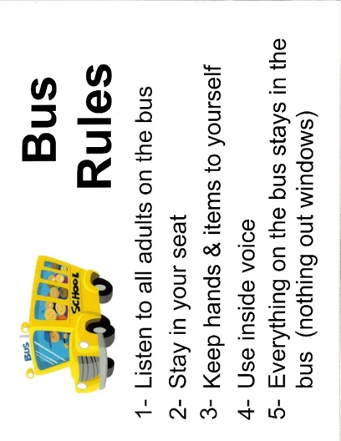

Students who follow these rules will help ensure the safety of themselves and others. Our drivers will make efforts to teach and remind students of these expectations. They will also look for opportunities to acknowledge students for good behavior.

In some cases, students may receive a positive ticket to recognize the good behavior of their students.

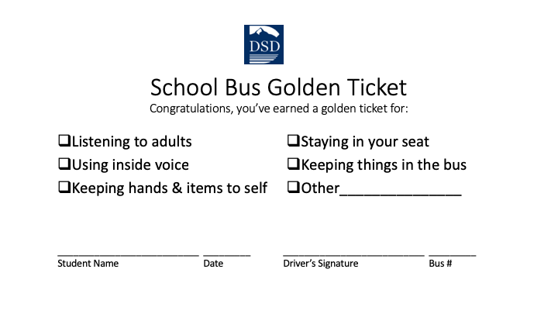

If students fail to follow a rule, they may be reminded of the expected behavior. The following behaviors will also warrant the completion of an incident report:

Misbehaviors leading to an office referral
- Repeated minor offenses  - Fighting  - Vandalism  - Refusing to follow directions  - Harassment or Bullying | - Inappropriate language  - Inappropriate materials  - Weapons  - Stealing  - Threaten to harm (self/others)

The principal will determine the appropriate action for the behavior and provide this incident report to you, the parent. Please review the information and sign it indicating you’ve read it. Please also work with your child to help them learn successful behavior in the future.

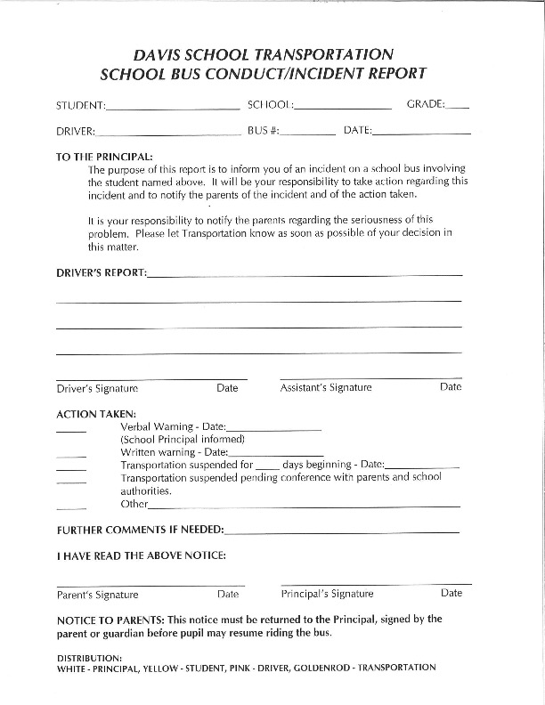

Please support your student by helping them learn how to behave in a safe and respectful way as they ride the bus. Please contact your child’s principal with questions or concerns.

