HERE ARE THE INSTRUCTIONS FOR FILLING AND SENDING THE UPDATED VERSION OF THE SAFTEY PLAYGROUND CHECK LIST.
#1: OPEN 6-7-2018 MASTER PLAYGROUND CHECKLIST AND IN THE UPPER LEFT CORNER, CLICK ON VIEW AND A DROP DOWM MENU WILL APPEAR AND CLICK ON “EDIT DOCUMENT”
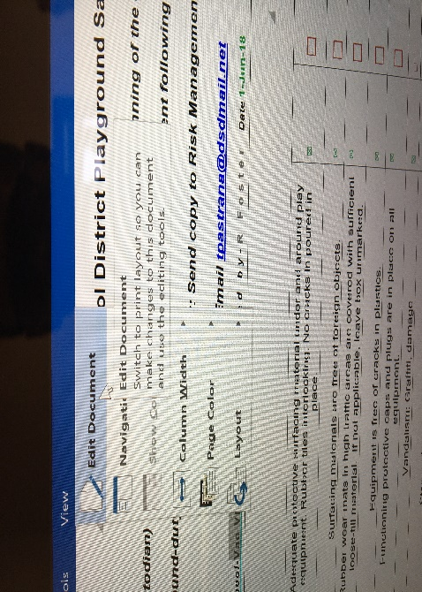
BELOW IS THE TOP PORTION OF CHECK LIST AND THE COLORED SECTIONS ARE WHAT NEEDS TO BE FILLED IN
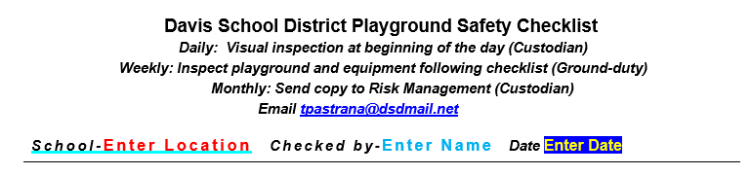
#2: DOUBLE CLICK ON RED”ENTER LOCATION” AND FILL IN
#3: YOU WILL REPEAT PROCESS FOR (DOUBLE CLICK)“BLUE ENTER NAME”
#4: ON DATE IN YELLOW AND BLUE, CLICK ON THE DOWN ARROW AND A DROP MENU WILL APPEAR, CLICK ON TODAY AND IT WILL INPUT TODAY’S DATE AUTOMATICALLY
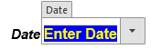
#5: CLICK IN ON YES OR NO BOX AND A “X” WILL BE INSERTED IN BOX
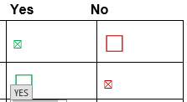

#6: YOU CAN FILL IN COMMENTS AT THE BOTTOM PAGE BY CLICKING ON “CLICK HERE TO ENTER TEXT.
#7: WHEN YOU CLICK ON “CLICK HERE TO ENTER TEXT WORDS DISAPPEAR AS YOU TYPE IN COMMENT.
#8 WHEN COMPLETED, CLICK ON FILE, THEN SAVES AS
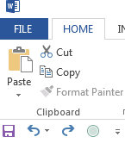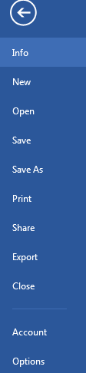
#9: SAVE AS IN MY DOCUMENTS OR WHERE YOU PREFER AND SAVE AS BIG, LITTLE TOY, N, S, E, And W OR WHATEVER YOU WANT TO NAME YOUR BIG TOYS. WHEN YOU SEND IN THE FOLLOWING MONTHS CHANGE THE DATE.
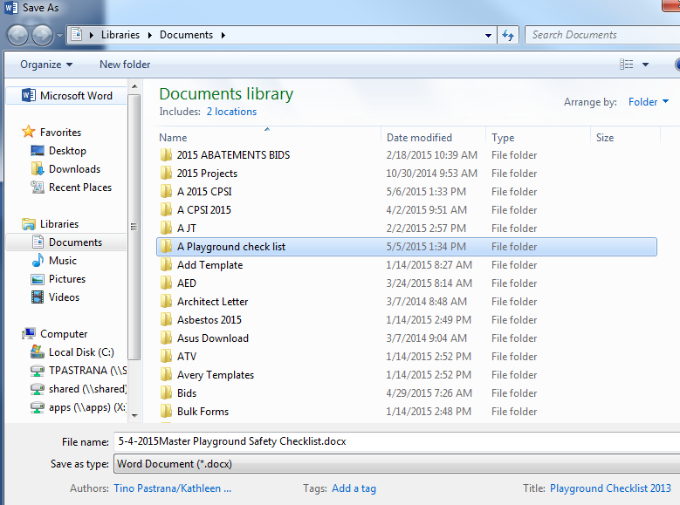
AFTER YOU HAVE SAVED THE CHECKLIST, HOLD DOWN CTRL BUTTON LOCATED LOWER LEFT ON YOUR KEYBOARD AND CLICK ON MY EMAIL AT THE SAME TIME, GROUP WISE EMAIL WILL COME UP AND ATTACH CHECKLIST TO MY EMAIL AND YOU ARE DONE. IF YOU HAVE ANY QUESTIONS CALL ME AND ILL TRY AND STOP BY AND “GETR DONE!”.
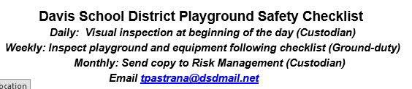
REMEMBER SEND ONLY THE END OF MONTH PLAYGROUND CHECKLIST. KEEP WEEKLY CHECKLIST @ LOCATION.

