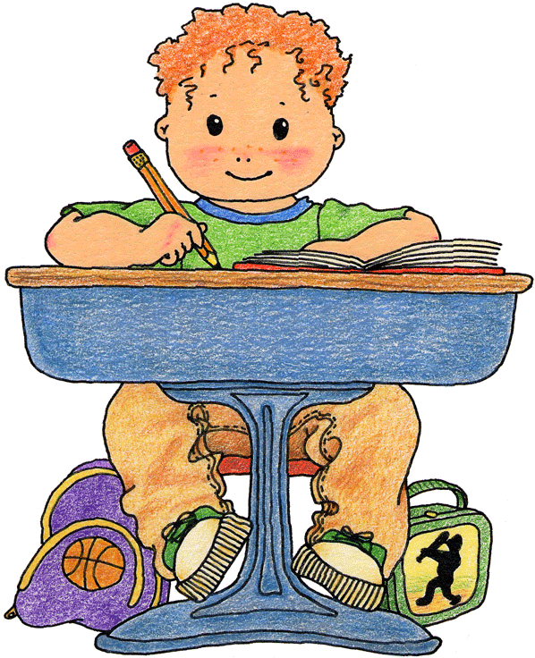
My Rules and Schedule
Sit
Follow Directions
Quiet
listen
Nice
Hands
Math

Scatter Groups
9:00 12:45
Science/
Social Studies

Prep
10:00 1:15
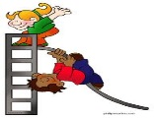
Recess

Recess
10:30 2:05
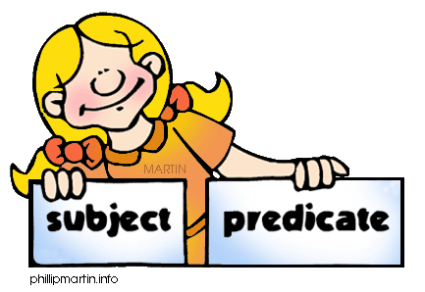

Resource
Writing
Writing
Math
10:45 2:30

Resource
Independant

Social
Skills
10:55 2:30

Lunch
12:05

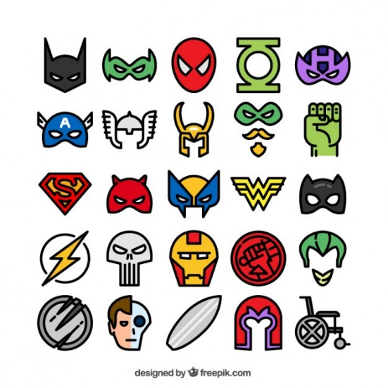

Picture Schedule with Velcro tabs- made to fit half size clipboard.
Directions:
Change the class to fit your students schedule
Print on cardstock
Cut outsuper hero figures you want to use.
Tape figures on back of side tabs so they can be seen when you fold the tab to the front.
Laminate,
Cut out on dotted lines
Tape to small- half size clipboard
Add slivers of Velcro to front of schedule and inside tabs to catch the front Velcro
Add two easy long strips to back of small clipboard to catch tabs when they are folded to the back

TTM for when we do not have scatter groups
at some point we will have Infinity
and Assembly
(1:25) on Fridays- Dismissal

